OOPS part 3:
FRIEND, STATIC, THIS, INITIALIZER LIST

Size of an empty class = 1

Size of virtual function?
It's simply a virtual pointer.
Size of pointer in 32-bit compiler = 4 bytes
Size of pointer in 64-bit compiler = 8 bytes

Ex:
class animal{
public:
int a;
char c;
virtual void barks(){
cout<<"animal barks"<<endl;
}
};

class cat : public animal{
public:
void barks(){
cout << "meow meow" << endl;
}
};

int main()
{
cat C;
animal *bptr = &C;
bptr->barks();

animal A;
cout << sizeof(A) << endl;
}
Output:
meow meow
12 (due to virtual pointer)

If we remove virtual, then output is
animal barks
8

Size of struct : https://aticleworld.com/structure-padding-questions/ - do questions here
1.Each data member should start from the byte number which is a multiple of size of that data member(index starts from 0)
2.overall size of the class should be the multiple of largest size data member according to that padding will be done at last

#pragma pack(push,1) means no padding anywhere
typedef struct
{
char B; // 1-byte
double A; // 8-byte
} InfoData;
#pragma pack(pop)
Ans : 9

(if u want u can leave this don’t give unnecessary stress to brain)
If we write #pragma pack(push,4) (we can only write powers of 2 inside pragma)
It treats the data members with size>=4 as size=4 -- for remembering
1.lets say size of data member is less than 4 ex:char it can start from its own multiple i.e multiple of 1
Size of data member >= 4 then it starts from multiple of 4
2.overall size = multiple of min(4, highestsize)

Ex1:
#pragma pack(push,4)
typedef struct
{
char B; // 1-byte
double A; // 8-byte
} InfoData;
#pragma pack(pop)
Ans : 12 (Typedef is to give a special name to defined data types)

Ex2:
#pragma pack(push,4)
typedef struct
{
double A; // 8-byte
char B; // 1-byte
} InfoData;
#pragma pack(pop)
Ans : 12

Ex3:
#pragma pack(push,4)
typedef struct
{
char A;
char B;
char C;
char D;
char E;
} InfoData;
#pragma pack(pop)
Ans : 5

Friend Class:
A friend class can access private and protected members of other classes in which it is declared as a friend.

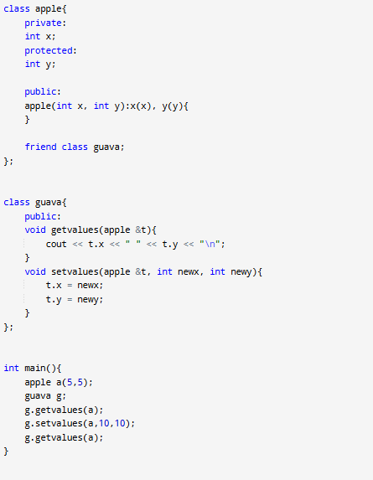
5 5
10 10

Friend function:
It is a function which is not present inside the class but can access private and protected members of the class.
Points:
1.friend function can be declared at any section of the base class i.e private, public and protected.
2.The keyword “friend” is placed only in the function declaration of the friend function and not in the function definition or call.

Real life example:
In Mobile fingerprint, along with our own fingerprint we can also add our friends fingerprint in the settings so that friend can also open the lock.
The concept of friends is not in Java.

a)friend function as global function:

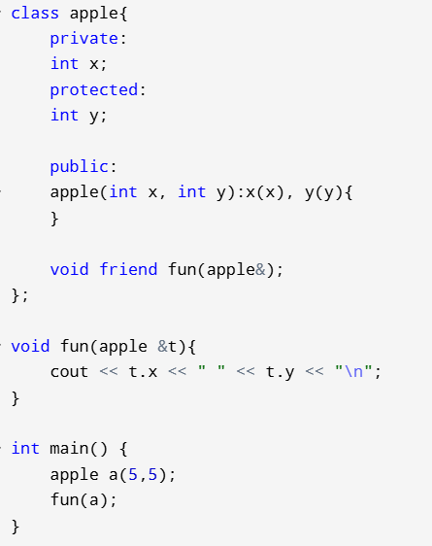
5 5

b)Friend function as a member function of another class:
Somewhat bigger code
Note: the order of defining classes and functions should be exactly like that. Think about it 🤔

Friendship is not inherited
Lets say some particular function is a friend function of Base class.
Now Derived class is inherited from the Base class.
Generally we expect that function can also access private data of derived class. But it cannot access.

Another important thing in the below code is that we are initializing base class members in derived class constructor using initializer list
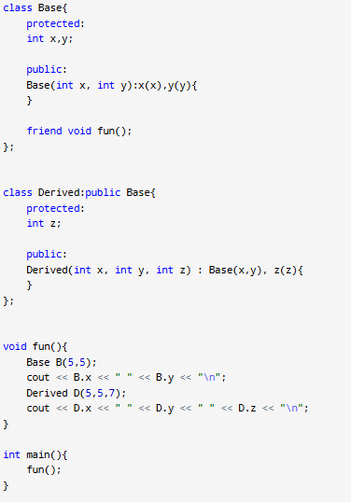
Compilation error because we are trying to access D.z
No problem in accessing D.x and D.y

"A virtual function can be a friend function of another class"
Ex:
class A; // Forward declare class A

class B {
public:
virtual void show(A& obj); // Virtual function in class B
};

class A {
private:
int data = 5;
// Declaring B::show as a friend of class A
friend void B::show(A& obj);
};

void B::show(A& obj) {
cout << "A's data: " << obj.data << endl;
}

int main() {
A objA;
B objB;
objB.show(objA); //A's data: 5
}

Another point to remember is any overridden function of show( ) cannot access restricted variables of class B

Static variables inside a function:
When a variable is declared as static inside a function, memory is allocated for the lifetime of the program.

void demo()
{
// static variable
static int count = 0;
cout << count << " ";
count++;
}

int main()
{
for (int i = 0; i < 5; i++)
demo();
return 0;
}

Output: 0 1 2 3 4

Static member variables inside a class:
When we declare a static variable inside a class, it says that there cannot be an individual static variable for each created objects. A single variable is shared by all the objects.

There can not be multiple copies of the same static variables for different objects. Also because of this reason static variables can not be initialized inside a class i.e static int count = 0; is wrong.
We can initialize the static variables of a class only outside of the class

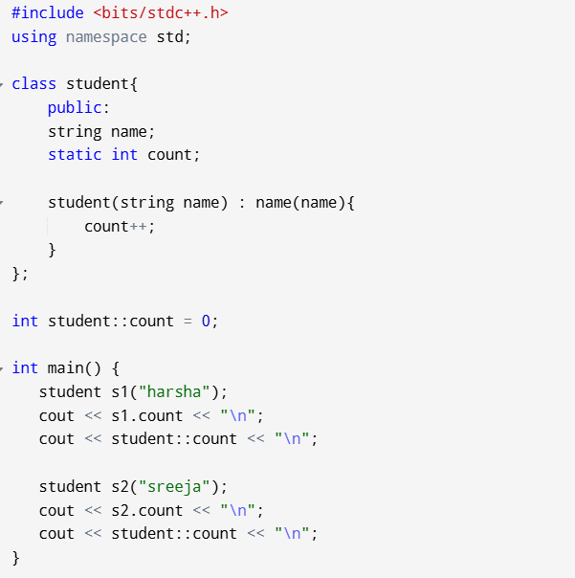
1
1
2
2

Static member functions inside a class:
A static member function is independent of any object of the class.

A static member function can be called even if no objects of the class exist.
A static member function can also be accessed using the class name through the scope resolution operator.

Static member functions are allowed to access only the static data members or other static member functions
because if it contains normal data variables of the class it will not be independent on the class.
But we can declare new variable which has no connection with the class, inside the static member function
(int data=4;)

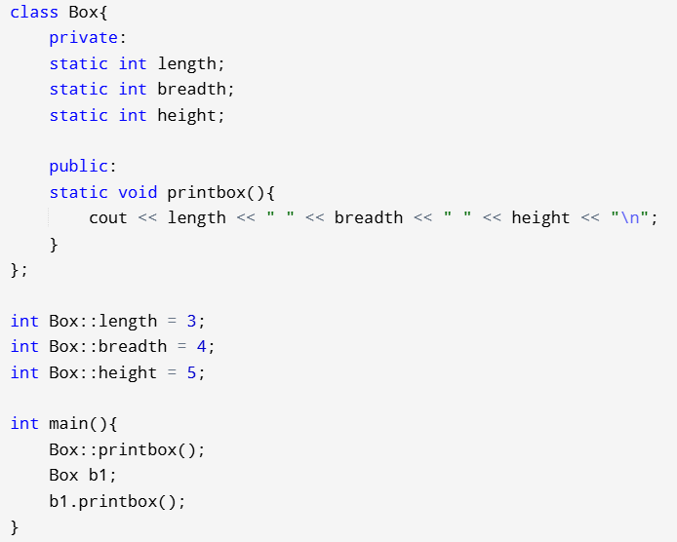
3 4 5
3 4 5

Static objects

Static member functions have a scope inside the class and cannot access the current object pointer.

Virtual functions cannot be static:
Virtual functions are used to achieve polymorphism, which allows a derived class to override a function in the base class. In runtime when you call the function through a base class pointer, appropriate function call invoked according to the object to which base ptr is pointed.
So somehow, in runtime it is object dependent.
But in contrast static functions are object independent

this pointer: It is simply a pointer pointing to current object
It is passed as a hidden argument to the non static functions in the class
below English matter is not manidatory
Each object gets its own copy of the data member. All-access the same function definition as present in the code segment. Meaning each object gets its own copy of data members and all objects share a single copy of member functions. Then now question is that if only one copy of each member function exists and is used by multiple objects, how are the proper data members are accessed and updated?
Ans : The compiler supplies an implicit pointer along with the names of the functions as ‘this’. The ‘this’ pointer is passed as a hidden argument to all nonstatic member function calls and is available as a local variable within the body of all nonstatic functions.
This pointer is not available in static member functions as static member functions can be called without any object (with class name).

Ex:
class Test
{
private:
int x;
public:
void setX (int x)
{
this->x = x;
}
void print() { cout << "x = " << x << endl; }
};

int main()
{
Test obj;
int x = 20;
obj.setX(x);
obj.print();
return 0;
}

When a reference to a local object is returned, the returned reference can be used to chain function calls on a single object.

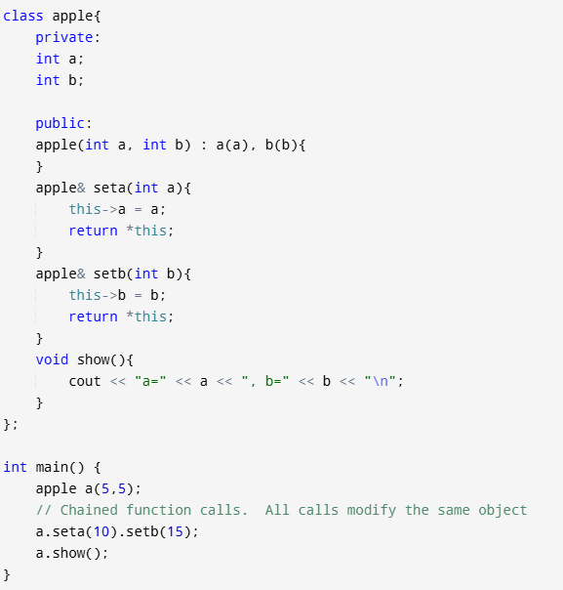
Output : x = 10 y = 20
Returning by reference avoids creating copies and is more efficient.

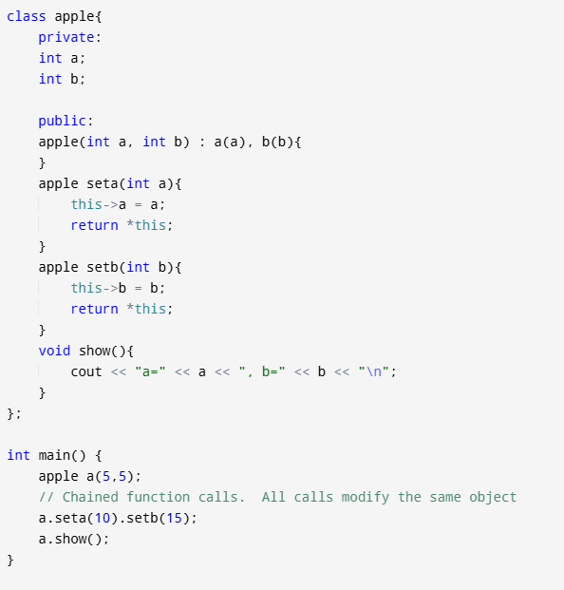
Output : x=10 y=5

Below 3 lines unnecesssary
For a class X, the type of this pointer is ‘X* ‘. Also, if a member function of X is declared as const, then the type of this pointer is ‘const X *’ (see this GFact) In the early version of C++ would let ‘this’ pointer to be changed; by doing so a programmer could change which object a method was working on. This feature was eventually removed.

class Test
{
private:
int x;
public:
Test(int x = 0) { this->x = x; }
void change(Test *t) { this = t; }
void print() { cout << "x = " << x << endl; }
};

int main()
{
Test obj(5);
Test *ptr = new Test (10);
obj.change(ptr);
obj.print();
return 0;
}
Output : Compilation error

https://www.geeksforgeeks.org/this-pointer-in-c/
Do 4 questions in this link

Initializer list: (always prefer this type of initialization only)
class Point {
private:
int x;
int y;
public:
Point(int xCoord, int yCoord) : x(xCoord), y(yCoord) {
}
};

int main() {
Point p1(5, 10); // Initialize point with x = 5 and y = 10
}

Here we are initializing the parameters, inside the constructors
But in normal code like
Point(int xCoord, int yCoord) {
x = xCoord;
y = yCoord;
}
We are assigning values to the parameters inside the constructor body which are already initialized

So initializer list is Efficient Initialization:
It is more efficient than assigning values inside the constructor body because the members x and y are initialized directly with the values, rather than first being default-constructed and then assigned.
If our data member is a data object, there we can observe difference clearly becoz of extra assignment operator call

Cases where we must use Initializer list:
Remember like this, in copy constructor we use (const A &t) from that, remember const, &, default constructor
a)Non static Constant data members:
A const data member must be initialized at the time of its creation because, by definition, it cannot be modified later.

class Test {
const int t;
public:
Test(int t):t(t) {}
int getT() { return t; }
};

int main() {
Test t1(10);
cout<<t1.getT();
return 0;
}

b) Reference Members:
A reference in C++ must always refer to a valid object or value when it is created, and it cannot be reseated to reference another object later (its reference, not a pointer mind it
class Test {
int &t;
public:
Test(int &t):t(t) {} //Initializer list must be used
int getT() { return t; }
};

int main() {
int x = 20;
Test t1(x);
cout<<t1.getT()<<endl;
x = 30;
cout<<t1.getT()<<endl;
}
Output:
20
30
We can change the value to where it is referencing but not the reference

c) For Initialization of Member Objects that do not have a Default Constructor
class A {
int i;
public:
A(int arg)
{
i = arg;
cout << "A's Constructor called: Value of i: " << i << endl;
}
};

// Class B contains object of A
class B {
A a;
public:
B(A &a) : a(a)
{
cout << "B's Constructor called";
}
};

int main()
{
A a(10);
B obj(a);
return 0;
}

Output:
A's Constructor called: Value of i: 10
B's Constructor called

Lets say we are assigning value to the data object inside the constructor body
There before assigning, default initialization should be done
But no default constructor for data object A

Parameter vs Uniform Initialization in C++: (uniform initialization is more restrictive)
It is better to use an initialization list with uniform initialization {} rather than parameter initialization () to avoid the issue of narrowing conversions.
It provides stricter type-checking during initialization and prevents potential narrowing conversions

class Base {
char x;
public:
Base(char a) : x( a )
{
}
void print() { cout << int(x); }
};
int main()
{
Base b( 300 ); // Using parameter initialization with ( )
b.print();
}
Output : 44

class Base {
char x;
public:
Base(char a) : x{ a }
{
}
void print() { cout << int(x); }
};

int main()
{
Base b{ 300 }; // Using uniform initialization with {}
b.print();
}
Output:
main.cpp: In function ‘int main()’:
main.cpp:17:17: error: narrowing conversion of ‘300’ from ‘int’ to ‘char’ [-Wnarrowing]
17 | Base b{ 300 }; // Using uniform initialization with {}

